Potential regulatory effects of Areg on Ghr experimental plan
Background
General Info:
Amphiregulin (Areg) is a member of the epidermal growth factor (Egf) family of ligands that binds to and activates the epidermal growth factor receptor (Egfr). It is synthesized as a transmembrane precursor (pro-AREG) that undergoes proteolytic cleavage to release its soluble, active form by Adam17. AREG plays a significant role in regulating cell proliferation, differentiation, and survival, particularly in epithelial tissues. It is expressed in various physiological contexts such as wound healing, tissue regeneration, and mammary gland development. Its expression is frequently induced by cytokines and growth factors, linking AREG to both immune responses and oncogenic signaling pathways.
Areg Expression info:
- Skin (when injured), Lung’s Treg (when injured), intestine (when infected)
- But primarily in the mammary gland, and specifically expressed in HormSens
A lot of expression sites all over the body, but Areg acts in a paracrine manner, so it is okay (?) to delete Areg/target Areg mRNA systematically.

Observation and (sub-)research question
Observation:
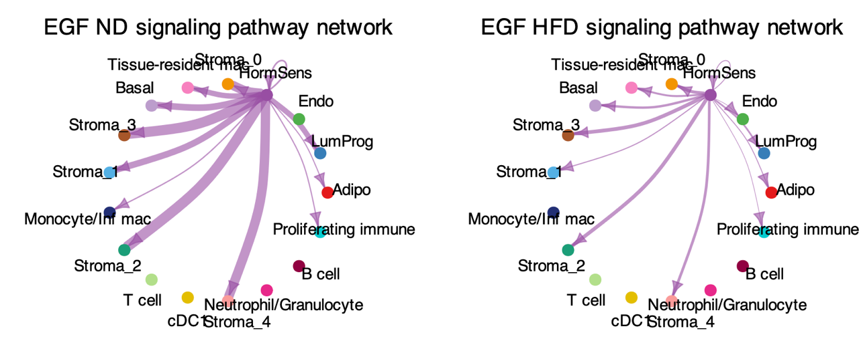
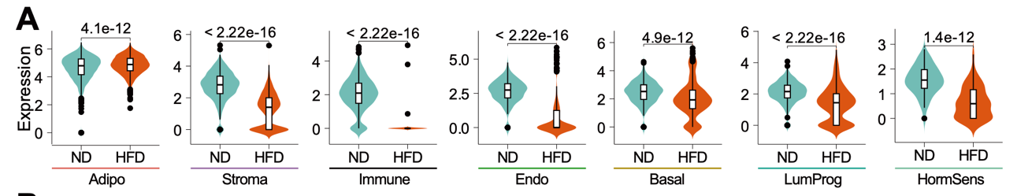
The Areg–Egfr signalling is decreased in HFD between HormSens and other cell types, except in Adipo cells (shown in the figure above). Correspondingly, the expression of Ghr (shown in the figure below) is downregulated in all cell types except Adipo.

Question: Why think Areg might regulate/be associated with the expression of Ghr?
- No prior report of this regulation.
- Reported: E affects Ghr expression in mammary gland.
- Hypothesis: This effect is partially mediated by Areg.

Experimental plan

1. Manipulate Areg
- Approaches (X Areg):
  - RNAi
  - CRISPR-dCas13 targeting RNA
  - CRISPRi targeting promoter/enhancer
  - CRISPR knockout
  - Adam17 inhibition with drug
- Verification (Ensure Areg is X):
  - qPCR
  - Immunostaining

2. Manipulate Egfr
- Approach (X Egfr):
  - Egfr antibody
- Verification (Ensure Egfr is X):
  - Western blot for phosphorylated EGFR (p-EGFR)
  - Immunostaining for total EGFR

3. Observe Ghr Expression
- mRNA level using: qPCR
- Protein level using: Western blot

4. Interpret Results

If Ghr is down:
- GH stimulation → measure pSTAT5 response.
- Rescue experiment: add exogenous Areg.
- X Egfr: evaluate significance — if the suppression remains, no further Ghr analysis is needed; focus on the physiological effects under HFD.

If Ghr is not down:
- Conclude that Ghr downregulation is not mediated by Areg deficiency.
- Future direction: check if Ghr expression recovers after switching to a normal diet (ND).
  - If not, consider drug-based interventions.

